For crew

WELCOME TO DAMEN VEROLME BOTLEK!

The closest town nearby is Rozenburg. It’s a nice 45min walk along the river Nieuwe Waterweg. It only has a few groceries stores, general stores and restaurants. See below a list with addresses. The shuttle bus will be going to Spijkenisse. Which is a bit larger and has a shopping centre and a wider variety on restaurants. Here you will also find public transport (metro) to Rotterdam. Payment can be done by debit/credit card (tab in/out). In Rotterdam you will find everything you need. From cheap to expensive. And good thing for those who would like to see the latest movies in a cinema. We use subtitles ;-)

The shuttle bus will stop in front of the dock on this large parking lot. See below map. This is also the pickup point for all disembarking crew and medical appointments. From the gangway to this parking lot there is a PPE free zone called Yellow Brick Road! Cycling is NOT allowed on the terminal but a bike can be taken by hand to the parking lot.

And most important one! Crew is NOT allowed to leave the Rotterdam area. So the Hague and Amsterdam and other places outside what we call the Rijnmond area are not allowed to be visited!

Shops in Spijkenisse / Rotterdam

- Action is like poundland
- HEMA is like M&S
- Kruidvat is like Bootz
- Holland & Barret
- Biggest Zara in the world in Rotterdam
- Primark in Rotterdam (city centre Rotterdam & Zuidplein)
- Zuidplein is a large indoor mall and has it’s own Metro station on the way from Spijkenisse to Rotterdam Centre

Supermarkets (download the app and create an account for discounts)

- Albert Heijn (AH) $$$$
- Jumbo $$$
- Lidl $$
- Aldi $$
- Dirk $$

Restaurants

- Fresh fries, best in town are from Bram Ladage. Try Patat Oorlog and Frikandel Speciaal 😉
- All you can eat Sushi, Shabu Shabu (Rotterdam)
- All you can eat Tapas, La Cubanita (Spijkenisse / Rotterdam)
- Of course you can find all mayor fast food restaurants in Rotterdam. Download the local app for the value deals.
- Various in the Witte de Withstraat / Rotterdam
- Popular in Rotterdam are the Surinam food places. Try broodje Dynamite (pork/chicken)
- And the famous Kapsalon (Kebab, Fries, hot and garlic sauce, melted cheese and salade)
- Pizza / Kebab shop in Rozenburg

Small guide to Rozenburg: Shops, Beauty, Restaurants & More

🛒 Shops & Supermarkets

- HEMA Rozenburg – Raadhuisplein 56-62, household & variety store
- Kruidvat – Raadhuisplein 7-9, drugstore / cosmetics
- Wibra – Raadhuisplein 52, discount / household
- DA Drogisterij & Parfumerie Richard – Raadhuisplein 54, drugstore
- Primera Rozenburg – Raadhuisplein 5, books, stationery, lottery
- Gall & Gall – Raadhuisplein 18, liquor store
- Meesterbakker Voskamp – Molenweg 67, bakery*
- Plus Klaassen – Emmastraat 84, supermarket
- Albert Heijn Rozenburg – Molenweg 71, supermarket
- Lidl - Laan van Nieuw Blankenburg 234, supermarket

💇 Hair & Beauty Salons / 💅 Nail Salons

- Kapsalon L. van der Linde – Molenweg 15
- Kapsalon Antonia – Emmastraat 28
- Sisher’s Kapsalon – Iependaal 11
- hAErtrend Rozenburg – Raadhuisplein 54B
- Haarmode Agthoven – Grote Stern 83
- Fedine Haarmode – Molenweg 49
- Latish Hair Beauty Salon – Raadhuisplein 15
- Calendulida Schoonheidssalon – Westererf 9
- Perfect Hands – Oranjelaan 25
- Salon Be You Tifull – Tulpenstraat 13
- Beauty By Char – Wilhelminastraat 12
- B. de Bruin (Beauty & Hair) – Reigerhof 40
- Karma (Nagelstudio) – Marjolein 8
- Love 4 Nailz – Rivierenlaan 54
- Just Love Them Nails – Appelgaarde 4

🍽 Restaurants & Cafés

- La Caleta – Spanish, Raadhuisplein 4a
- Brasserie Noortje – Lunch/dinner/high tea, Emmastraat 26
- Pancho – Middle Eastern, Emmastraat 2A
- Pizzeria La Sicilia – Italian/Pizza, Emmastraat 76
- Golden House – Asian/Chinese style, Emmastraat 34
- Ni-Hau – Chinese take-away, Molenweg 69
- De Veerheuvel – Nieuweweg 1a
- ’t Hofplein – Dutch café, Molenweg 55
- LEEN Restaurant & Club – Lunch & dinner options
- Cafetaria Arnolds – Snack bar, Nachtegaallaan 50
- Baghdad – Pizza / Greek / Turkish, Raadhuisplein 22
- KFS – Turkish grill / kebab, Molenweg 32
- Misa’s Takeaway – Döner / Turkish pizza, Emmastraat 6

Interesting places to see and shop in Rotterdam

- Markthal in Rotterdam
- Cube houses Rotterdam
- Old Harbour Rotterdam
- Maritime Museum in Rotterdam
- Feyenoord stadium tour in Rotterdam
- Euromast in Rotterdam
- Miniature world in Rotterdam
- Diergaarde Blijdorp (Zoo) Rotterdam
- Pathé Theater (cinema’s) Various locations in Rotterdam.
- Pannekoekstraat is particularly good: small-scale, independent fashion, accessories, vintage, etc., plus cafés and atmosphere.
- Nieuwe Binnenweg / Oude Binnenweg , Long & eclectic shopping streets. A mix of fashion boutiques, vintage stores, music shops, design & gift-shops, cafés and laid-back restaurants.
- Witte de Withstraat, Artsy & cultural. Galleries, alternative boutiques, hip cafés, good for art lovers & people who enjoy a more creative, offbeat atmosphere.
- Van Oldenbarneveltstraat, More upscale boutiques & designer shops, luxury brands, charming fashion stores and cosmetics. Good if you like more premium / curated fashion.

Address for crew mail and online shopping delivery

- Amazon items can be send to our office address but needs to be clearly marked “Vessel name + crew name”
p/a S5 Netherlands
Hoefsmidstraat 40
Hoogvliet 3194 AA
Netherlands
- We will deliver twice a week (Tuesday & Thursday)
- No charges from our side
- We will not be responsible for lost packages

Shuttle buses for crew to central Rotterdam

- There will be no shuttle bus to Rotterdam but to Spijkenisse Metro Station
- Started at 09.00 from the yard.
- Departing from the yard on the whole hours
- Departing from the Metro station on the half hours
- Lunch break between 13.00 and 14.00 hrs
- Evening break between 20.00 and 21.00 hrs
- Last bus back from Spijkenisse to the yard at 23.30 hrs
- This service is for crew only!
- Some cards like Revolut are not accepted by public transport

Wifi for crew

- No unfortunately not

Local customs restrictions and any declarations regarding alcohol, cigarettes etc

- It will not be allowed to sell any tax free items during the DD period! This has to do with the fact that you are not been used a cruise ship, during a DD they will see you as a “regular” ship. I know, not what you hoped for.
- So on the bonded stores declaration we need ALL tax free items mentioned on the document. So including the stock in all the bars.
- Spirits: All alcoholic beverages with an alcohol percentage of 22.0% or higher.
- Other alcoholic liquids: All alcoholic beverages with an alcohol percentage below 22% (excluding beer and wine, which are reported separately).
- When counting “Spirits” and “Other alcoholic liquids,” it does not matter whether the bottles are in bar stock or shop stock.
- When counting “Spirits” and “Other alcoholic liquids,” all bottles that are more than 50% full must be included in the total stock (in liters). Bottles that are less than 50% full do not need to be included.
- The moment you send the document nothing can be taken out of the bonded store anymore.
- Reckon that customs will board during the DD period.
- Make sure that ALL the names of the officers are noted by the security
- Call the agents when they board
- Crew who are onboard on arrival can put the regular free allowance on the Personal Effects list. Embarking crew are not allowed to.
- Crew can buy tax free from the outside tax free shops but are not allowed the used before leaving the port.

Immigrations or Not / Crew and Contractors

Crew
- On Signing via Immigrations
- Off Signing via Immigrations

Passengers (contractors)

- Contractors are to be divided by 3 categories.

- All contractors who are embarking and disembarking in Rotterdam are not to be seen by immigrations. This is what we call day visitors. And also NOT to be mentioned on the local format PAX list!
- All contractors who embarked in Southampton and disembark in Rotterdam need to be seen by immigration in there office. See below addresses and opening hours. If we don’t organize the transport then they are responsible to pass by. Not passing by can cause a penalty! This is not for the ship. Dutch citizens are not be seen by immigrations.
- All contractors who embarked in Rotterdam and will sail with the vessel to Southampton will be seen by immigrations the day before departure onboard.

The contractors sailing with the ship need to mentioned as following on the local format PAX list. Also this PAX list must be a complete overview in the end. So once someone has left the vessel it still needs to be on the PAX list.

In transit (Southampton – Southampton)

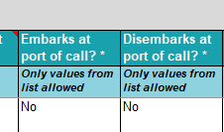

Disembarking (Southampton – Rotterdam)

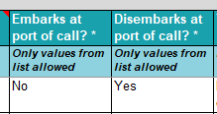

Embarking (Rotterdam – Southampton)

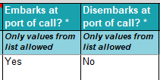

As said immigration will board the vessel the day before departure and will need to see all embarking contractors. Please advise the number of these contractors in the course if the DD period in order to inform immigrations accordingly.

- 3/4 immigration officers will board at 10.00 hrs (to be confirmed in the days before departure).
- They will check ALL contractors who boarded the vessel in Rotterdam and will sail with you to Southampton. All others can keep working.
- Please have 3 copies ready with the names
- Please set up an area, preferred close to a window for good internet connection where they can work (incl. Coffee/tea/juice small snacks just to keep them happy 😉 ) They are not allowed to have a lunch onboard.
- To avoid a large line of people waiting can we call them via the PA on nationality.

Immigrations Botlek (close to the yard)
Zeehavenpolitie
Neckarweg 50
3197 KX Botlek Rotterdam
Open Monday to Friday from 07.00 till 15.00 hrs

Immigrations Rotterdam City Centre
Zeehavenpolitie
Sint-Jobsweg 6
3024 EJ Rotterdam
Open 24/7

Entry/Exit the yard

- All pick up transfers will be from the parking lot in front of the ship.
- Only embarking crew/contractors will be going via the main entrance of the yard.
- From the vessel towards the exit there will be a PPE free zone (Yellow Brick Road)
- It’s allowed to take a bike but it’s not allowed to cycle on the yard!

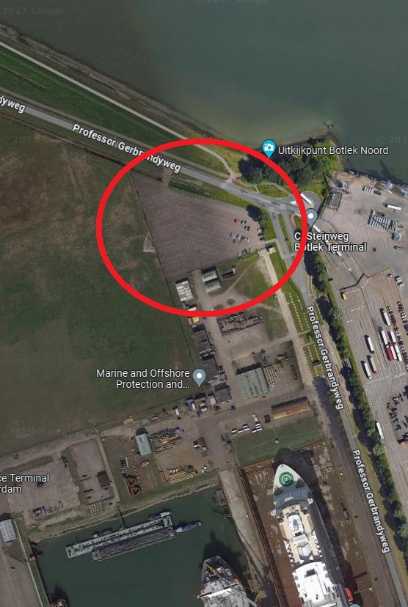

Parking for contractors / shuttle bus / medical crew transfers / disembarking crew

