Overview: Norwegian Medical Certificate Verification Changes
From 1 June 2026, the Norwegian Maritime Authority introduced a new registration and verification process for Norwegian seafarer medical certificates and declarations of unfitness. This overview explains what has changed, what remains the same, and what ships and crew office teams need to do when checking Norwegian medical certificates when presented at Crew Sign-on.
Key message: Norwegian medical certificates remain paper documents. The main change is that the new certificate format includes a QR code and can be verified digitally where needed. The original paper certificate must still be brought on board and retained as required.

What is new or changed?
New & Changed | What this means for ships and crew office teams
QR code added to the certificate | Ships can use the QR code to support quick validation of the certificate where internet access is available.
Digital verification available | Validity and official status can also be checked through the Norwegian Maritime Authority verification portal where required.
Certificate layout has changed | Teams may see a revised format during sign-on checks; this does not automatically mean the certificate is invalid.
Transition period applies | Different versions of the Norwegian medical certificate may exist and remain valid during the transition period.
Internet access may be needed | Ships and the Crew Office teams should allow for Wi-Fi or internet access if digital validation is required in the terminal.

What has not changed?
- The certificate continues to be issued by an approved seafarer’s doctor.
- Seafarers will continue to receive a paper version of the Norwegian medical certificate.
- Medical certificates are not issued electronically under the current STCW requirements (except for Bermuda Medical Certificates, which went digital in May 2025)
- The original paper medical certificate must still be brought on board by the seafarer and retained as required.
- Existing internal medical clearance and onboarding processes remain unchanged unless a separate process update is issued.

What teams need to do
- Crew Office: continue to validate and record Norwegian medical certificates in line with the current compliance and onboarding process. Be aware that both old and new certificate formats may be valid during the transition period.
If verification is needed, use the QR code or verification portal where internet access is available.
- Global Talent Partners (GTPs): continue to guide seafarers on approved medical examination requirements and next steps where medical clearance or restrictions apply.
- Revenue Business Partners, Academy and Entertainment teams: ensure concessionaires and guest entertainers obtain a valid Norwegian medical certificate from an approved seafarer’s doctor where required and retain the original paper certificate for joining.
- Crew Compliance & Onboarding Compliance: support stakeholder awareness; clarify the change where required. For the Onboarding team, they must continue to validate and record Norwegian medical certificates in line with the current compliance and onboarding process. Be aware that both old and new certificate formats may be valid during the transition period

When to verify
- Verify the certificate if the format is unfamiliar; details appear unclear, or confirmation of validity is required during embarkation checks.
- Use the QR code on the certificate where available, or the Norwegian Maritime Authority verification portal.
- If digital verification cannot be completed due to connectivity, follow the current escalation route and do not assume the certificate is invalid solely because online validation is unavailable.
Key contacts
• Seafarer Fitness: crewmedical@carnivalukgroup.com
• Crew Compliance: crewcompliance.support@carnivalukgroup.com
• Crew Hub: Crew Compliance Medical page

Note: The Norwegian Maritime Authority does not publish a blank standard template for the seafarer medical certificate. Certificates are issued by approved seafarer doctors through authorised systems. The appendix below provides redacted examples to help teams recognise the previous format and the revised QR-enabled format now in use.

Appendix
The examples below are provided for reference to illustrate the previous certificate format and the revised Norwegian medical certificate format now in use.
Appendix A: Previous version of the Norwegian seafarer medical certificate
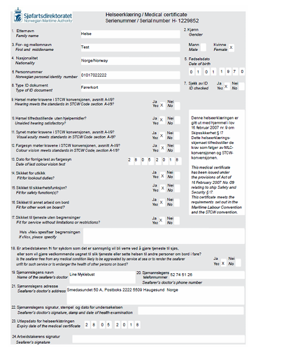

Appendix B: Current Norwegian seafarer medical certificate with QR code for verification
