New Digital Bermuda Medical Certificate

What’s New?
As of the 1st of May 2025, all Bermuda Medical Certificates issued by an approved Doctor will be issued in a digital format only. Newly issued Bermuda Medical Certificates confirming that a seafarer is Fit for Sea will be uploaded into the Bermuda Online Seafarer System (BOSS) by the approved Doctor or their Medical Administration team.

How does it impact me?
You will receive an email with a PDF copy of your Bermuda Medical Certificate. It includes a QR code in the top right corner and a hyperlink to BOSS at the bottom. The serial number will serve as a unique identifier for verification by you, your GTP, or an external auditor.
All medical certificates (hard copies & digital versions) are checked and validated as part of your compliance checks during your onboarding journey.

Current Bermuda Medical certificates remain unchanged. Crew members will keep a hard copy of their medical certificate until they receive a digital version from Bermuda.

Key Reference Points
The images below show the Bermuda Medical Certificate, including the unique tracking number (BOSS serial number) and QR code for reference.

New Bermudan Medical Certificate
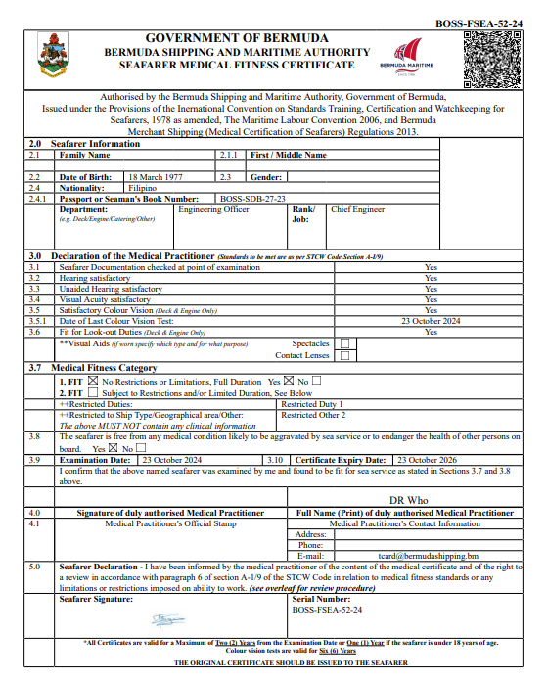

BOSS certificate verification page via QR code.

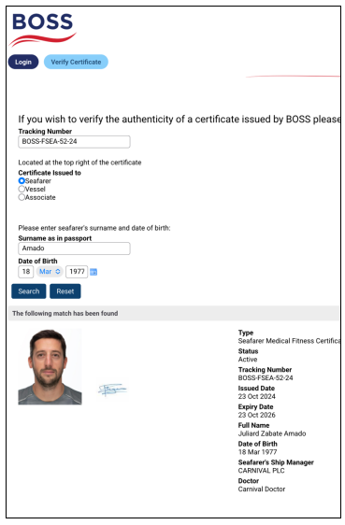
Should you have any questions, please contact your GTP.

