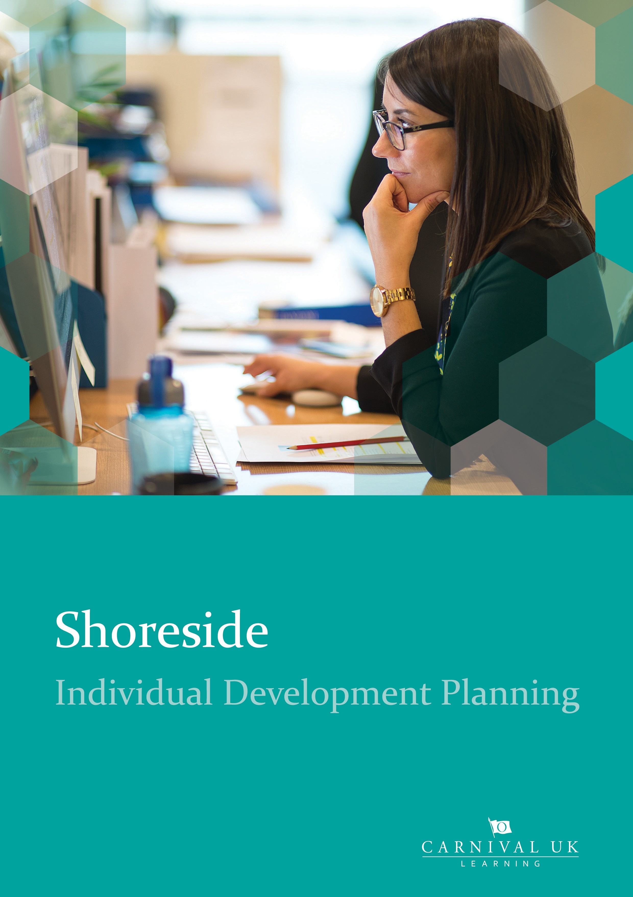

2

Individual Development Planning
Individual Development Planning

Your guide to creating your development plan…
Your Individual Development Plan is an effective way to help you focus on developing in your current role and / or preparing you for future opportunities. Use this document to guide your development discussion with your line manager identifying important goals for personal development and considering different ways to do this, applying a 70:20:10 approach.

This guide will help you:

Prepare for your development discussion and discuss with your manager Capture the outputs from your discussion
Input your development goals into MyHR Portal Review and revise

Prepare for your development discussion and discuss with your Line Manager
As well as setting your objectives, you and your manager should regularly discuss your strengths and areas for development. Including; your current knowledge, skills, behaviour and career aspirations. This will help you and your manager agree your personal and professional development plan.

To help you to think about where to focus your development goals, consider the 3 step approach and the questions below that will support a development conversation with your manager.

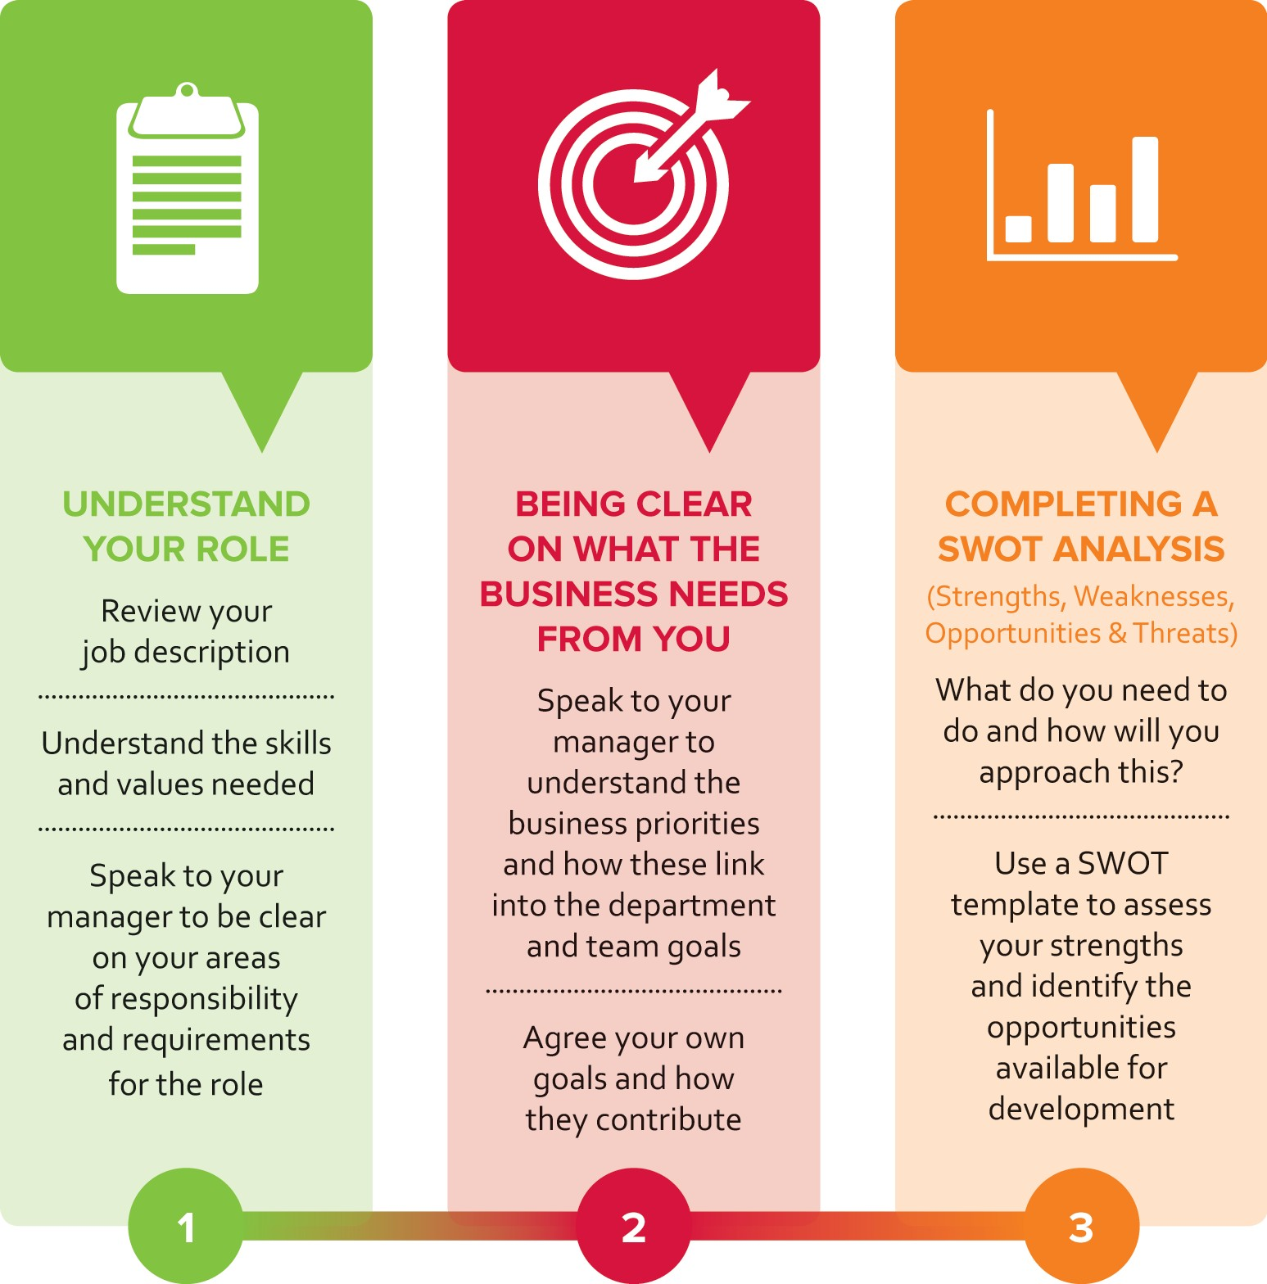

3


Ask yourself these questions...
Individual Development Planning

Your current role
What are your strengths in your current role?
What more could you do to develop your strengths further?
Are there any areas where you could increase your knowledge, skill or experience, to excel in your current role?
Who could you seek feedback from, to help you identify any areas of focus?
Who do you know who consistently demonstrates the skills or behaviours you are looking to improve?

Your career aspirations

What do you want to achieve in your career?
What aspects of your current role do you enjoy the most?
What knowledge, skills or behaviour do you need to develop, to support your career aspirations? Can you identify anyone who currently does this role or demonstrates these skills?

Focussing your development goals

What are your priority areas of focus for your development? (we recommend 1-3 goals) What support do you need to help you achieve this?
How can you apply the 70:20:10 approach, when identifying the actions you will take? What does good look like for this goal?
How will you know when you have achieved this development goal? What is realistic timeframe for you to achieve or review this goal?

Carnival UK Values and Leadership Expectations

How do you currently demonstrate the Carnival UK values? Which values would you like to focus on developing further?
Which Leadership Expectations would you like to focus on developing? What support and resources do you need to help you achieve this?
How will you apply the 70:20:10 approach, when identifying the actions you will take?


Try It, Discuss It, Learn It – 70:20:10

Try It, Discuss It, Learn It – 70:20:10

The best way to develop is often unique to you and your particular experiences and preferences. Development needs can flex and change over time, due to changing personal or work circumstances.

70:20:10 describes an ideal balance between different ways of learning and developing.

The 70:20:10 approach tells us that effective learning can take place any time, anywhere and under anyone’s guidance, and that we need a mix of methods to be able to learn.

‘Try It’ through day-to-day tasks, challenges and practice. ‘Discuss It’ through collaboration and sharing, in person or online. ‘Learn It’ through more formal learning such as a course or completing a qualification.

4

5

Here’s some things to think about when planning your development:
Try It, Discuss It, Learn It – 70:20:10

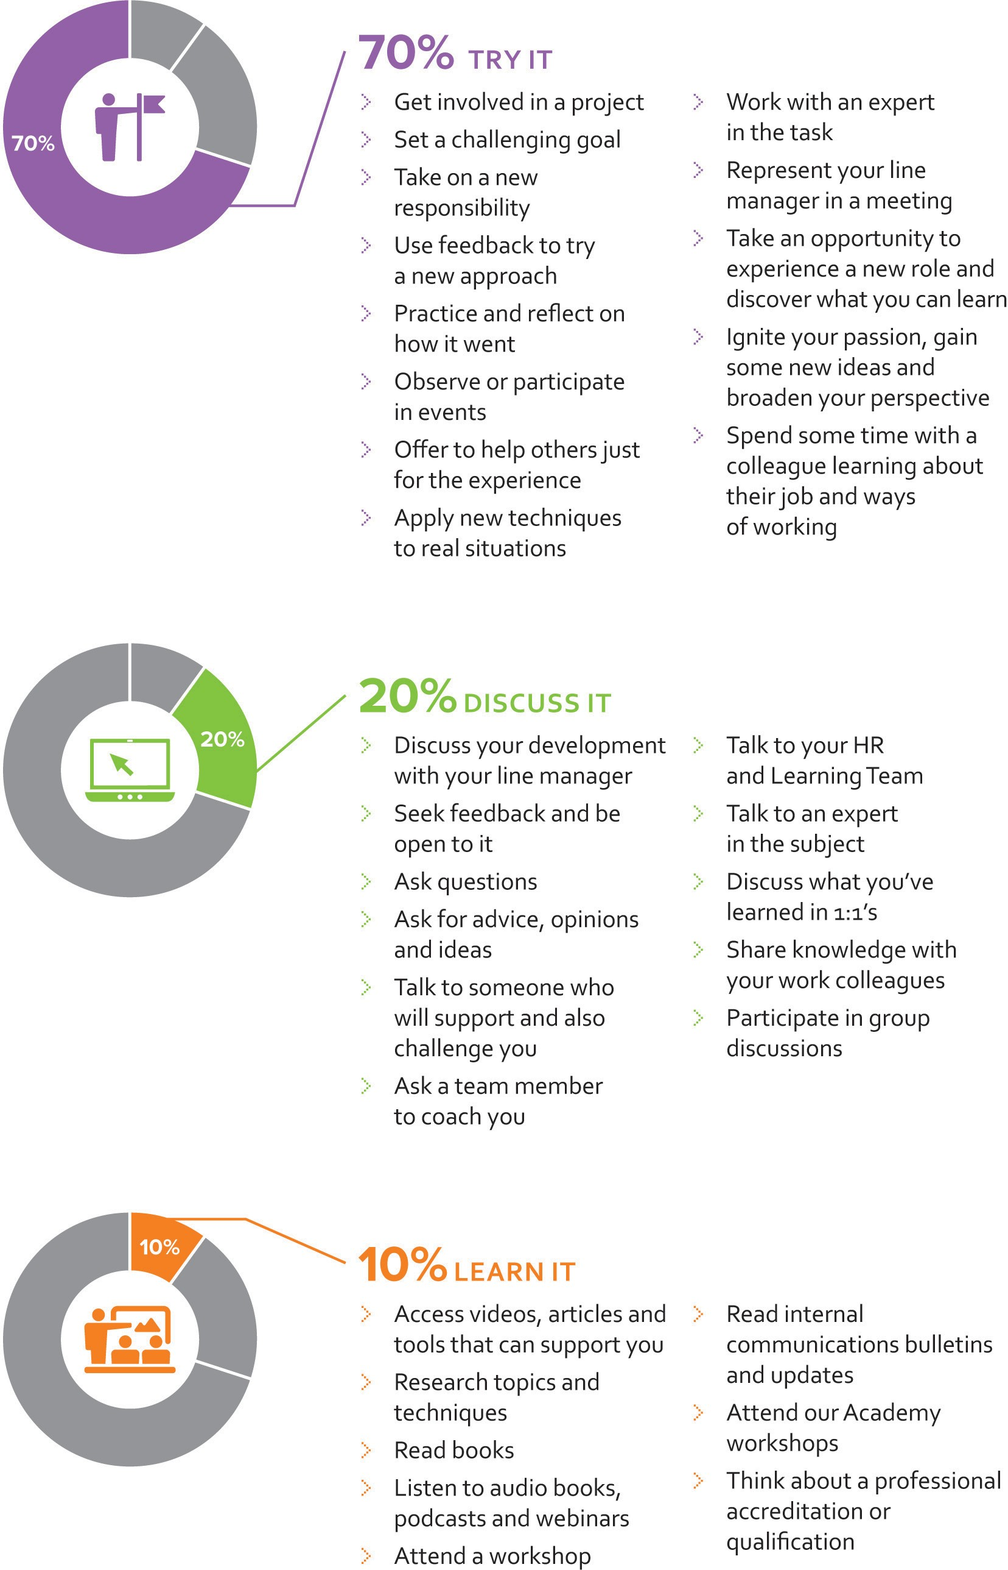

6


MyHR Portal
MyHR Portal

Capture the outputs from your discussions
Once you have discussed your development focus with your manager you can together agree your goals, as well as how and when you aim to achieve them. You will need to capture the outputs from your discussion and enter your development goals into the HR portal.

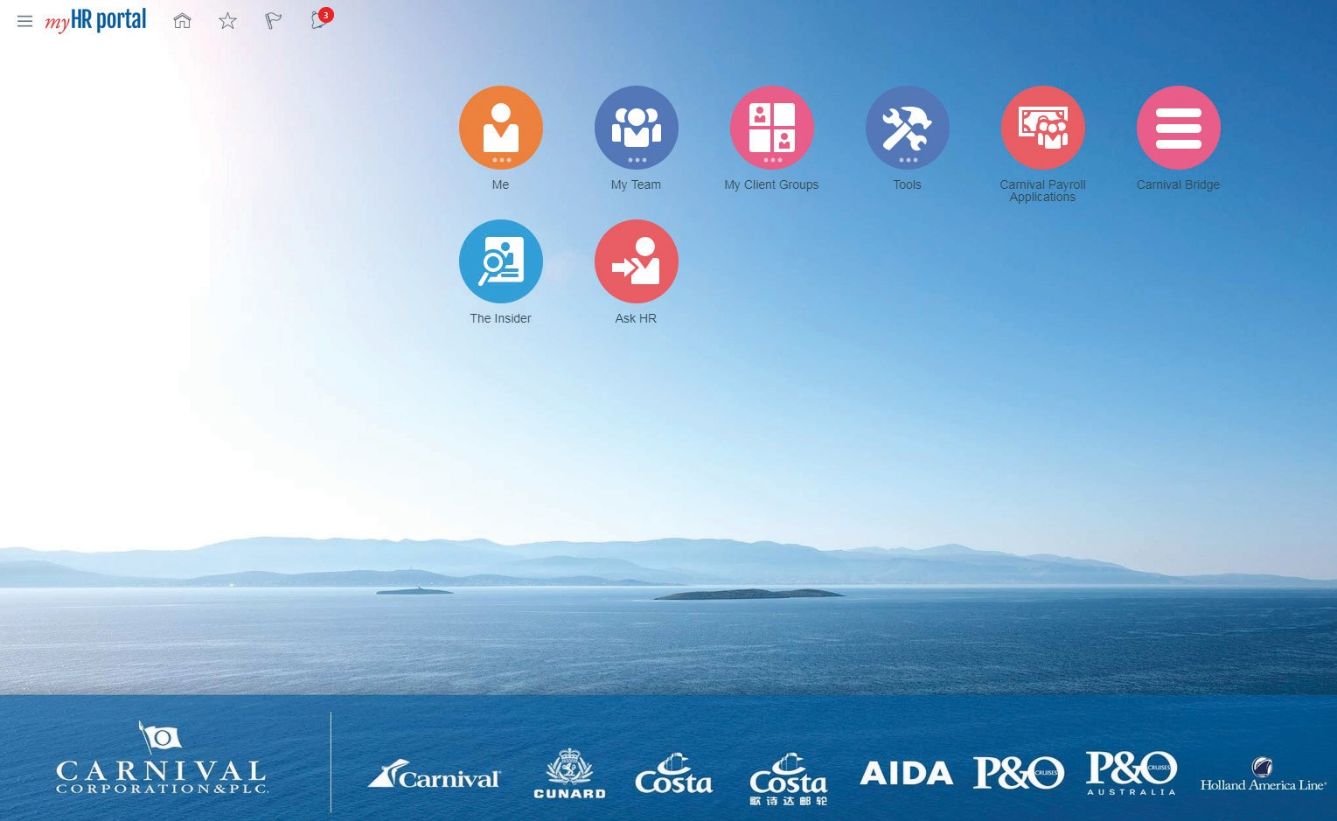

Input your Development goals into MyHR Portal
MyHR Portal enables you to capture your development goals. In order to do this follow these steps:

Open The Insider intranet homepage Hover over Quick Links
Click MyHR Portal
Click on Company Single Sign-On
Click on Home icon
Click on Career and Performance

Click on Career Development
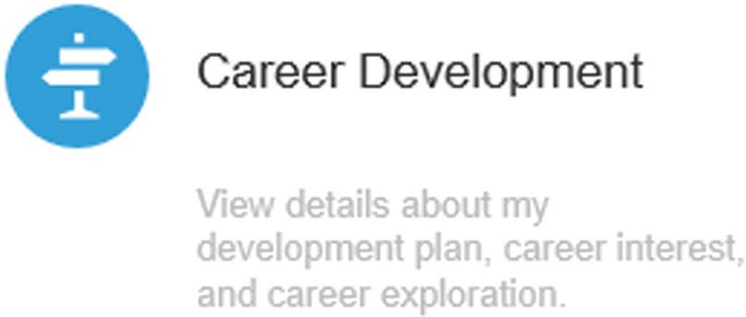

7

Once the next screen opens, click on Add Goal, then New Goal
MyHR Portal
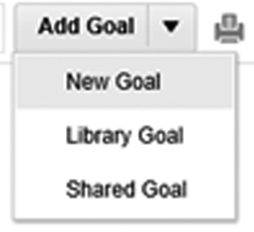

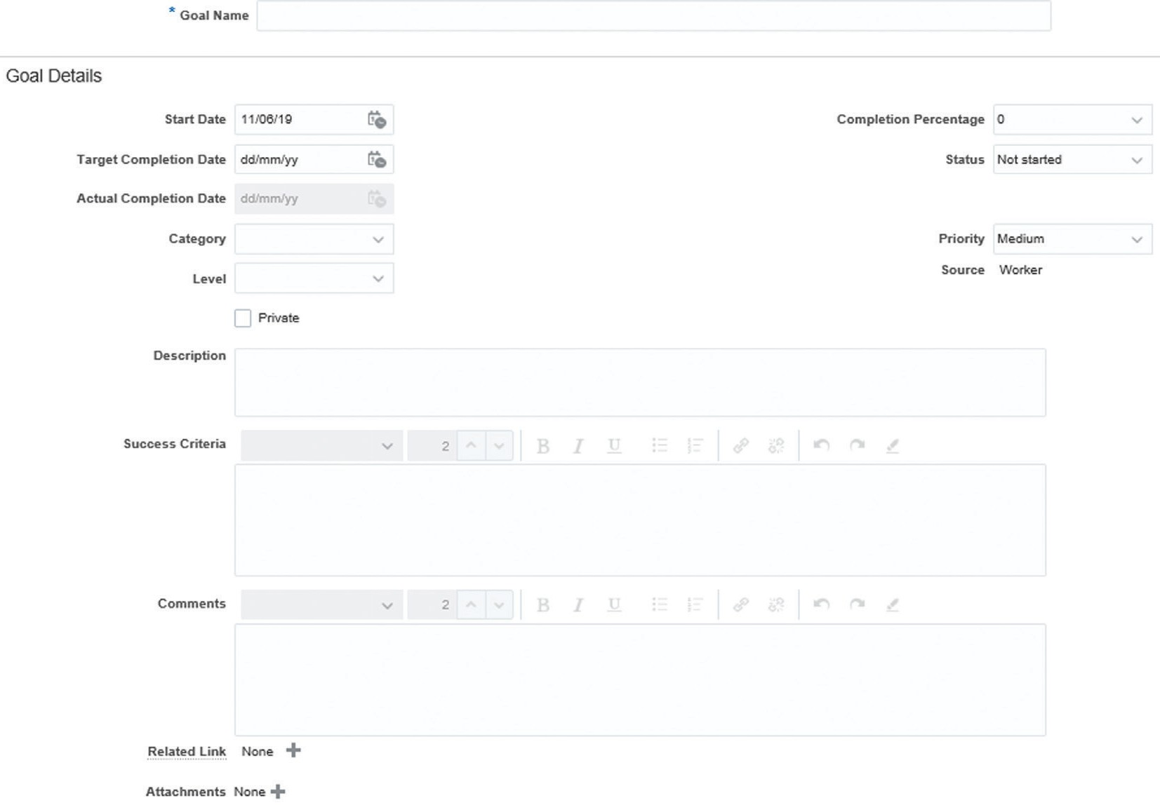
Goal Details

Enter Goal Name
Enter the Start Date that you will start working on your development goal
Enter the Target Completion Date that you intend to complete your development goal Enter the Status – Not started / In-progress / Completed
Select the Category – Short / Medium / Long Term Select Level – Stretch or Target
Enter the Priority for the goal – Low / Medium / High
For the Description use your conversation notes to capture your development goal For the Success Criteria use your conversation notes to capture these questions:
How will you know when you have achieved your goal? What will success look like?
Use the Comments box to capture any other information about your development goal (i.e. behavioural development or the 70:20:10 approach to learning)
Once you have finished entering your information, click save and close (top right)

8

Development Plan Questionnaire
Development Plan Questionnaire

Your name: | Start date:
Manager name: | End date:

Development Goals

What are the top 3 priorities you want to achieve? | How will you know when you’ve been successful? | When do you want to achieve this by?
Priority 1:
Priority 2:
Priority 3:

Behaviours

Carnival UK values – what behaviours do you want to work on?
Passionate about Happiness | Heroes of Safe & Well |  | Determined & Courageous
Better Together |  | Guest Obsessed
Leadership Expectations – what behaviours do you want to work on?
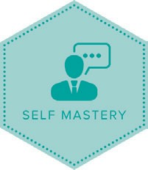  Self Mastery  Act with high levels of self-awareness, authenticity  and integrity. | 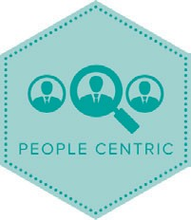  People Centric  Make things sustainably better for all. Build relationships, collaborate and develop talent. |  | 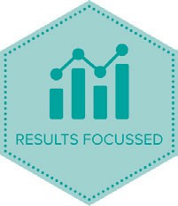  Results Focussed  Take responsibility, maintain commitments. Focus on purpose, vision, strategy, goals.

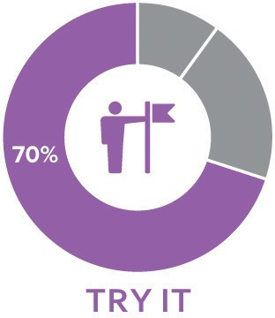
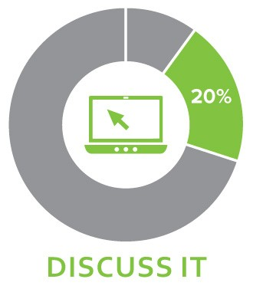
9
Development Plan Questionnaire

What support and resources will I need to achieve this goal?
Check in date with manager on progress:

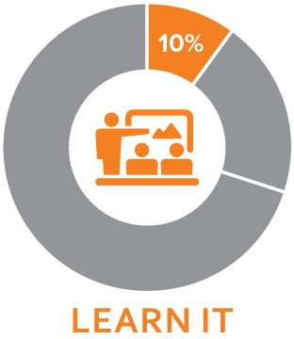
Review and revise
You should regularly discuss your development goals with your manager during your 1:1’s and in your quarterly enabling conversations. During these conversations consider the following questions:

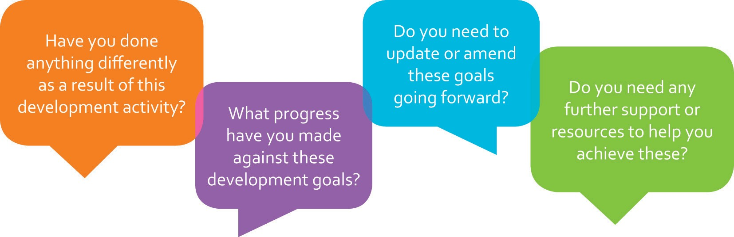

For more information on the 70:20:10 approach and our CUK Leadership Expectations, please access The Learning Academy via The Cove, our social learning platform.



